MOTOR PEDAL LISTING INFO
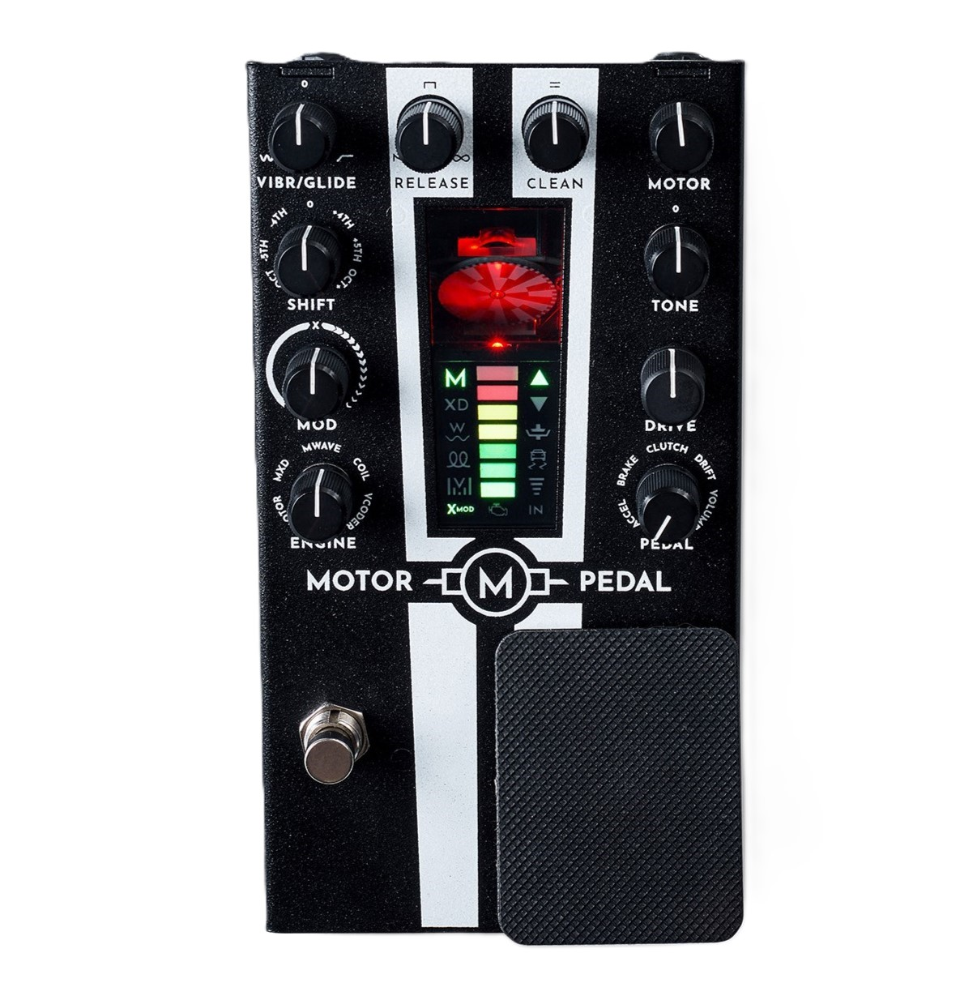

SKU INFO
Launch Date 29th of September 2025
Product name | MOTOR Pedal
Full name in listings | Gamechanger Audio MOTOR Pedal
Additional title | Electro-Mechanical Synth Voice and Harmony Pedal with Pitch Shifter, Pitch Tracking and Pressure-Sensitive Foot Controller
Manufacturer’s SKU | GCAMP
UPC | 750258555295
Product category | Effect Pedals
Manufacturer | Gamechanger Audio
Made in | Made in EU, Riga, Latvia

PRODUCT PHOTOS AND VIDEOS
Product photos:
https://drive.google.com/drive/folders/161djJDt7QH2MgOkvcrDToq1QKLoE-Fa3?usp=sharing

Suggested videos:
Promotion demo by Gamechanger Audio https://youtu.be/wIA8qAFXSzQ?si=BnGNE3_vuaBWFqDO
Full Features video by Gamechanger Audio https://youtu.be/l1DKfuNbi9Y?si=Kixmmj_oDx3j1Bw0
Junkyard Jam by Gamechanger Audio https://youtu.be/QBaQ_nSVJu4?si=wZoP9zaqM7ms_Slo

User manual:
https://gamechangeraudio.com/wp-content/uploads/2025/08/MP_manual_v05_WEB_lo.pdf

PRODUCT DESCRIPTION
The MOTOR Pedal is a fully playable electro-mechanical synth voice that tracks your pitch in real time. Use it as a drone that doubles your lines, or as a ring-mod or cross-modulation engine for your signal. This isn't an emulation or analog modeling — this is the sound of a spinning brushed DC motor, pushed to the edge and tamed with precision control.
The MOTOR Pedal uses a real-time pitch tracker to analyze your instrument's output. Whether you're using a guitar, a bass, or a microphone, the motor's rotational speed will precisely match the fundamental frequency you're playing. For example, to match a 440Hz input, the motor will rotate at 146 revolutions per second, activating the magnetic pickup and sensors three times per rotation.
A carefully calibrated inductor captures the real-world motion of the motor's spinning coils, transforming mechanical energy into a raw, electric audio signal.

The MOTOR Pedal's unique features and modes allow you to use it for much more than a simple synth voice:
- FOOT PEDAL - An innovative foot pedal with normal and floor-it ranges, and five unique pedal modes.
- MOTOR - Raw electromagnetic pickup of the spinning coils. Glitchy, growling, magnetic.
- MXD - Cross-modulation of the motor with a digital waveform, creating harsh, distorted, and metallic textures.
- M-WAVE - A digital oscillator that's pitch-locked and hard-synced to the motor's output. A multitimbral synth with an imperfect mechanical soul.
- COIL MODE - Instead of spinning the motor with DC voltage, this mode injects alternating current into the motor's coils to create resonant analog vibrations and metallic hums. This innovative synthesis method sounds like nostalgia on steroids.
- VOCODER MODE - A 24-band digital vocoder that uses the motor's output as the carrier and your instrument's signal as the modulator. Speak, sing, or shred directly through the machine.
- ANALOG TONE BOOST - A powerful tilt equalizer for shaping the motor output.
- TWO VOLUME KNOBS - Independent volume control for the dry signal and motor output.
- MOTOR DRIVE - Heavy analog distortion for the motor output.
- ENVELOPE - Go from short, punctuated stabs to an envelope follower to long releases.
- GLIDE - Applies a portamento curve to the motor engine.
- VIBRATO - Classic pitch modulation, from subtle movement to wild oscillation.
- MOTOR INTERVAL SELECTOR - Allows you to offset the motor pitch by +/- 1 octave or perfect fifths or fourths.
- X-MOD MODE - Use amplitude modulation to cross-modulate the input signal with all motor engines.
- ACCELERATOR - Create a wide range of controlled pitch shifts, or "floor it" to redline the motor.
- BRAKE - Downward pitch shift, or mash the pedal to bring the motor to a stall.
- CLUTCH - Temporarily disconnect the motor from the pitch tracker—perfect for creating drones.
- VOLUME - Use the spring-loaded pedal to create satisfying volume swells.
- DRIFT - Play the pedal like a gentle vibrato arm, or just "floor it" to get a complete wipeout.
- Power: Powered by a standard 9V DC center-negative power supply with at least 500 mA (not included).
- Connectivity: Additional 5-pin and USB-C MIDI functionality.

The MOTOR Pedal uses a specially-designed brushed DC electromotor block as its core sound engine. Over time, the motor's brushes are going to erode, and the motor block will need to be replaced - indicated by the pedal's check engine light turning orange and then red. The motor block is a replaceable part with an estimated lifespan of 3,000–5,000 hours of intensive playing. Installing a replacement motor is comparable to changing a set of tubes in your amp.

FEATURES / BULLET POINTS
- A fully playable electro-mechanical synth voice that tracks the pitch of your playing in real time.
- A real sound source of a real electromotor that spins “in pitch”.
- Innovative expression foot pedal with standard and floor-it ranges and selectable modes of accelerate, brake, clutch, volume swells, and drift.
- Five engine modes to select between magnetic pickup, cross-mod, multitimbral, resonant, and vocoder.
- Track in, track out, and MIDI functionality to source the signal from anywhere in the signal chain.

TECHNICAL SPECIFICATIONS
Connections
IN MONO | 6.35mm (1/4’’) TS socket
TRACK IN | 6.35mm (1/4’’) TS socket
MIDI IN | MIDI 5 PIN DIN cable input
OUT MONO | 6.35mm (1/4’’) TS socket
TRACK OUT | 6.35mm (1/4’’)TS socket
USB-C | MIDI & Firmware update
Sound
Source | Built-in analog signal multiplier (X-mod) and 5 MOTOR synthesis modes
ENGINE | MOTOR, MxD, MWAVE, COIL, VOCODER
MOD | Waveshaping, timbre and analog signal multiplier depth
SHIFT | -Oct, -5th, -4th, 0, +4th, +5th, +Oct
VIBR / GLIDE | Max vibrato: +/-100c, max glide: 5
RELEASE | 200ms to infinite
DRIVE | Analog hard-clipping drive circuit
TONE | Analog tilt boost/cut EQ, Fc=300Hz, +/-6dB
CLEAN | Analog CLEAN channel volume mixer
MOTOR | Analog MOTOR channel volume mixer
Expression | Built-in spring-loaded expression "accelerator" pedal
PEDAL | ACCEL, BRAKE, CLUTCH, DRIFT, VOLUME
Indication
MOTOR DISC LED | Red LED shining on disc indicating effect on/off
ENGINE LED bar | Indicates selected ENGINE
REV LED bar | Indicates current motor RPM (in COIL mode: pitch)
PEDAL MODE LED bar | Indicates built-in expression pedal mode
X-MOD LED | Green when MOD knob is on the right side. White when receiving a signal
ENGINE LED | Motor module health status
IN LED | Green when receiving an input signal. Blue when receiving MIDI input
Signal specification
IN / OUT / TRACK IN / TRACK OUT | 4Vpp max
Audio Input impedance | 500 kOhm
Audio Output impedance | 100 Ohm
Motor System
Motor Module Assembly | Type 030 brushed DC motor, encoder and pickup assembly - GCA partname: MMB1
Min speed: | 400 rpm (20Hz)
Max speed: | Range 26000 ... 42000 rpm (1300Hz ... 2100Hz) depending on power supply (9V 500mA ... 9V 1A)
Other
DC Power input | Center negative 9-12 V, Minimum 500 mA,  2.1 x 5.5 mm plug
Product Dimensions (with Knobs) | 18 x 10 x 8 (cm) / 7.1" x 4" x3.2" (L x W x H)
Product Weight | 1.07kg / 2.4lbs
Package Shipping Dimensions | 21 x 14 x 11 (cm) / 8.3" x 5.5" x 4.3" (L x W x H)
Package Shipping Weight | 1.17kg / 2.6lbs

