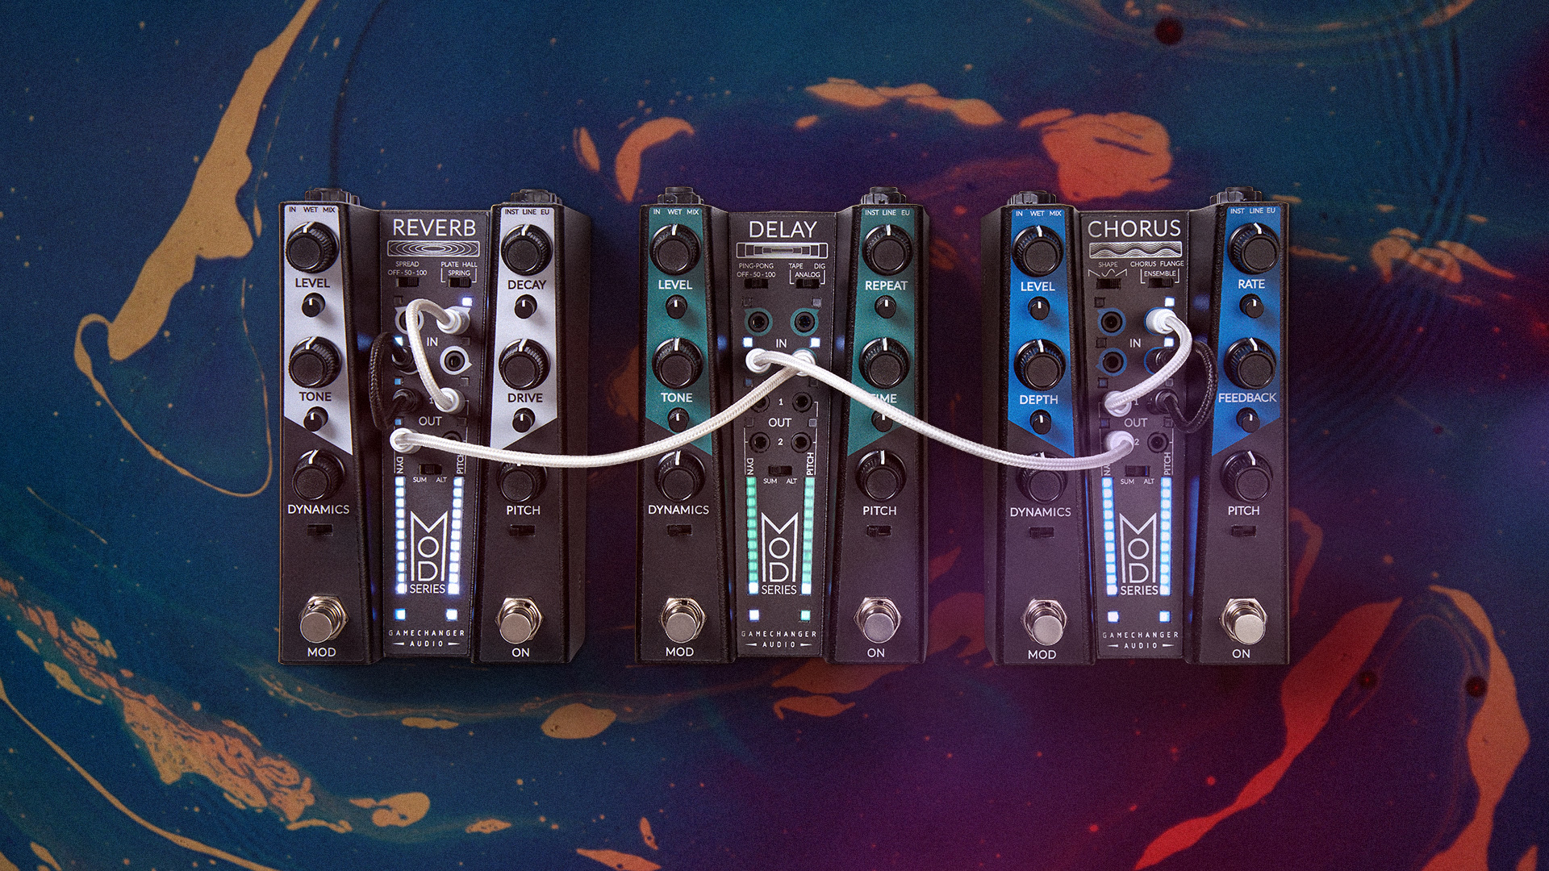

Gamechanger Audio redefines guitar effects pedals with their new release - The MOD Series.

Gamechanger Audio is proud to announce the release of its groundbreaking MOD Series, a unique blend of classic pedal design and modular synthesis mastery. This series marks not just an advancement in audio processing but a complete reimagining of pedal capabilities.

They say that tone is in the fingers - The MOD Series transforms the musician's performance into an integral part of the sound effect. Players' touch, dynamics, and note choices become the primary architects of sound, creating tones and textures that evolve in real-time with their performance. This integration of sound design and musical expression invites musicians on a journey of endless exploration and discovery.

[VIDEO] LINK: https://youtu.be/ICscZxVbwc4?si=LJVTR1sPPqucm-5j

The GAMECHANGER AUDIO kicks off the new series introducing the first three pedals - MOD Delay, MOD Reverb, and MOD Chorus.

Unique to the MOD Series, each pedal features dynamics and pitch following engines that are controlled directly by the musician's performance.
The DYNAMICS function captures the nuances of playing volume, reflecting the character of picking style and instrument decay.
The PITCH tracker responds to note selection, bends, and vibratos.
Standard 3,5 mm TS patch cables (included) give players the power to direct these modulations to any of the four effect knobs, dynamically altering effects.

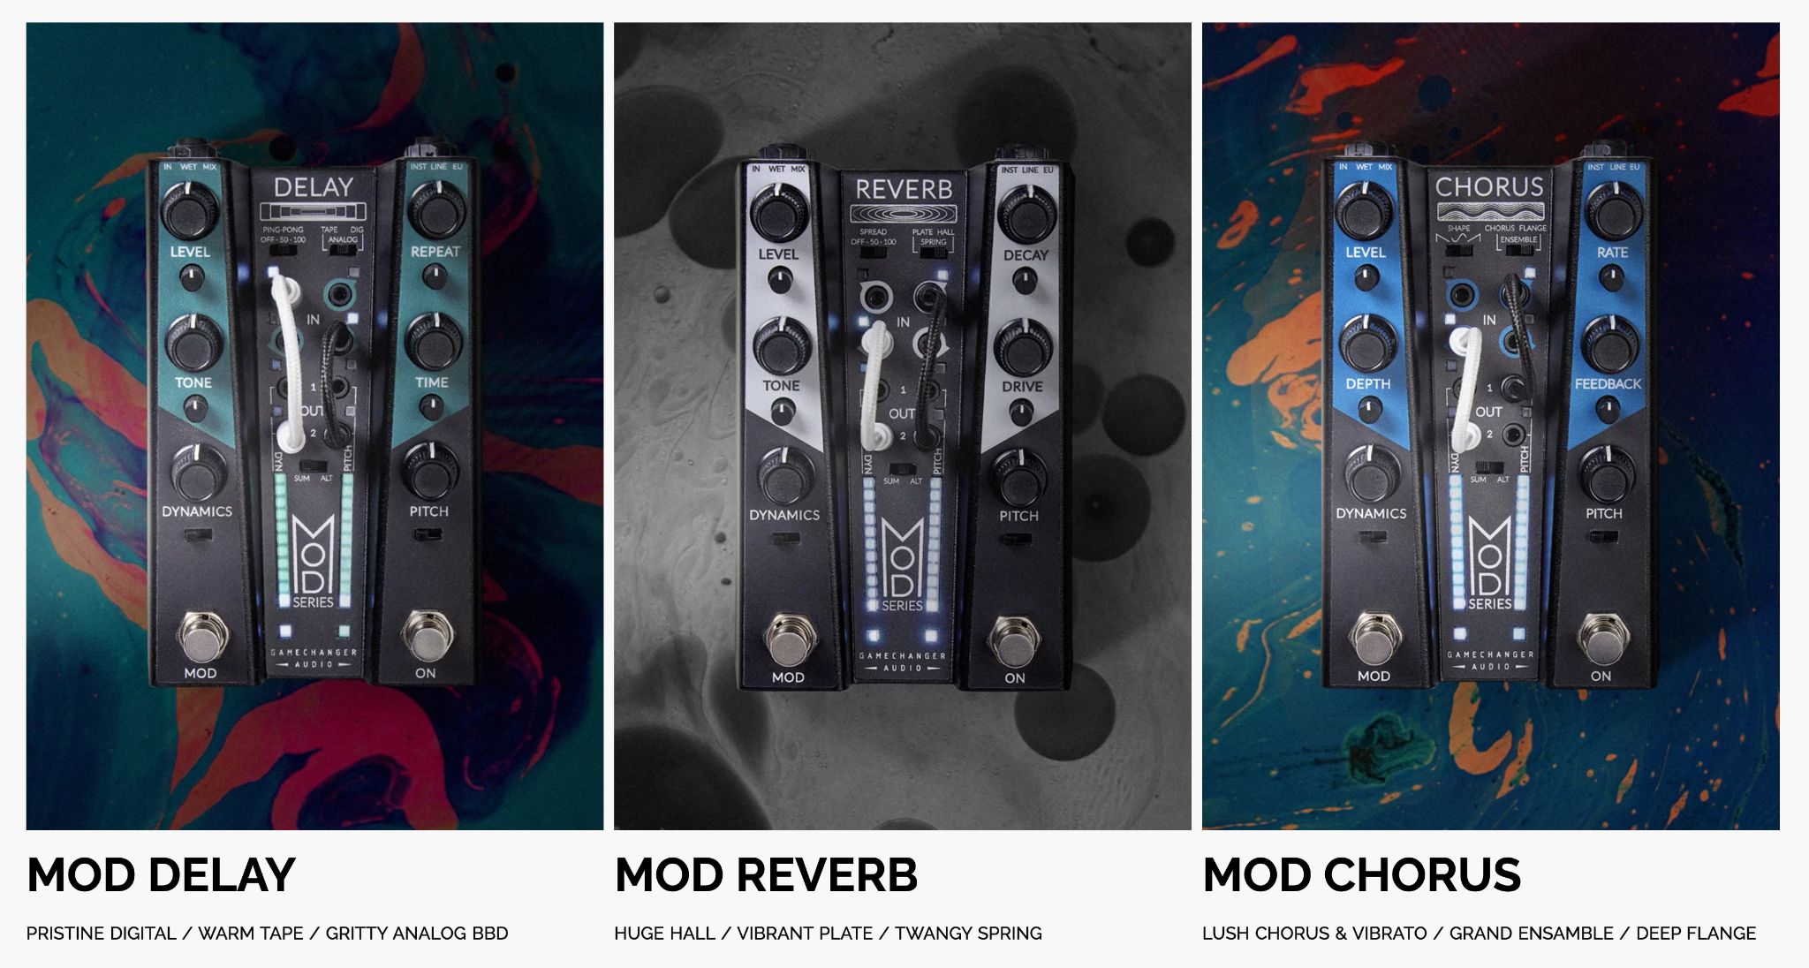

MOD reverb features:
- 3 algorithms: PLATE, SPRING and HALL
- 4 streamlined controls: LEVEL, DECAY, TONE, DRIVE
- 3 stereo spread settings: 0%, 50%, 100%

MOD Delay features:
- 3 algorithms: TAPE, ANALOG and DIGITAL
- 4 streamlined controls: LEVEL, TIME, FEEDBACK, TONE
- 3 PING PONG panning settings: 0%, 50%, 100%
- MIDI or analog clock synchronization
- Tap tempo

MOD Chorus features:
- 3 algorithms: CHORUS, ENSEMBLE and FLANGE
- 4 streamlined controls: LEVEL, DEPTH, RATE, FEEDBACK
- 3 shapes: SAWTOOTH, SINE, RAMP

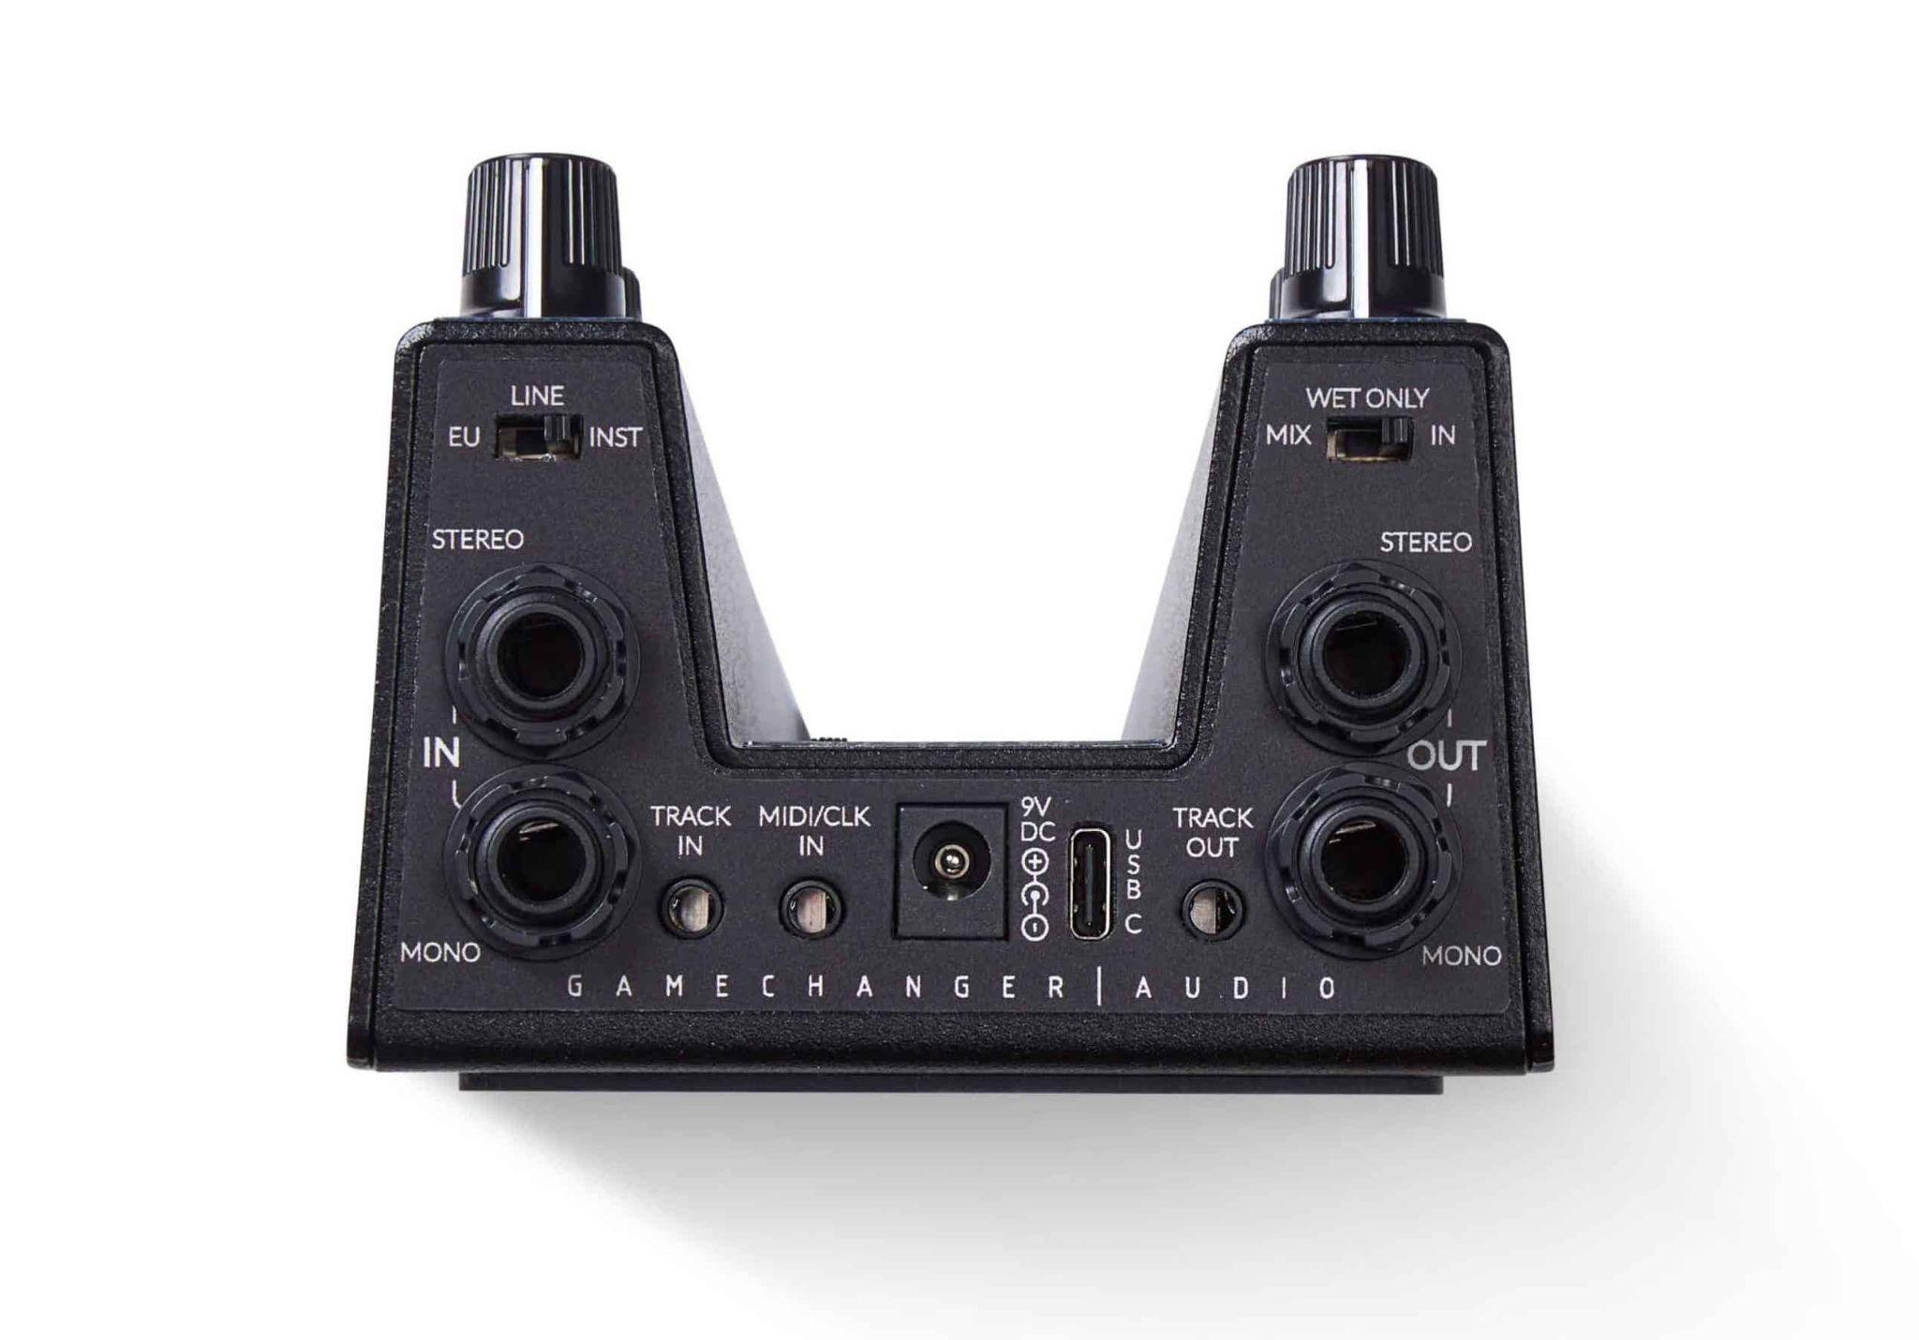

Inputs and Outputs and Setup:
- Stereo and mono signal processing. Stereo routing is possible both using regular TS mono cables or TRS stereo cables.
- Switchable input level: INSTRUMENT, LINE or EURORACK
- Switchable LEVEL knob functionality: INPUT LEVEL + DRY SOUND, INPUT LEVEL + KILLDRY or DRY/WET MIX
- TRACK input for routing an auxiliary signal for controlling the modulation.
- TRACK output for passing the TRACK input further or for dry signal output.
- MIDI/CLK input for MIDI clock or analog trigger sync for time base effects.
- 9V DC center negative power inlet. Power draw of 250 mA max depending on effect.
- USB-C input for future updates.

The MOD Series offers an alternative to conventional effect changes typically achieved through presets, expression pedals, and MIDI controls. This series emphasizes the artist's skill, allowing for the orchestration of effects through instrument play.
Targeted at sound explorers, the MOD Series offers a combination of easy-to-use interfaces and profound sound manipulation possibilities. The series challenges musicians to delve into their creativity and discover extraordinary sounds beyond the usual.

The MOD Series pedals are available at USD 299 from gamechangeraudio.com and dealer network starting 1/24/24.

About Gamechanger Audio:

Gamechanger Audio, a pioneering audio tools manufacturer hailing from Riga, Latvia, is one of the leading innovators in the music technology industry. Their impressive lineup of products showcases their unwavering commitment to pushing the boundaries of music technology:
The PLUS Pedal: A groundbreaking creation, the PLUS Pedal is the world's first sustain and sostenuto pedal, designed to elevate the potential of not only guitars but all melodic instruments.
PLASMA Pedal: With its high-voltage audio circuit, the PLASMA Pedal has redefined signal distortion by transforming live instrument signals into continuous high-voltage discharges within a xenon-filled tube.
PLASMA Rack: This 1U high-end audio effects unit extends the PLASMA technology into the professional and studio realm.
PLASMA Drive: Developed in collaboration with Erica Synths, the PLASMA Drive module brings the innovative distortion effect to the eurorack format.
MOTOR Synth: This electro-mechanical wonder takes analog synthesis to the next level, by utilizing electromotors as oscillators, delivering a totally unique and inspiring palette of sounds.
LIGHT Pedal: Setting a new standard, the LIGHT Pedal is the world's first analog optical spring reverb system, using infra-red optical sensors to capture the full range of timbral and harmonic nuances within a spring reverb tank.
BIGSBY Pedal: Designed in partnership with Fender, this revolutionary polyphonic pitch shifter pedal reproduces the string bending and vibrato effects produced by the BIGSBY Tremolo arm and other traditional tremolo systems.
PLASMA Voice Eurorack Module: PLASMA Voice is the first PLASMA product that doesn't need an external sound source and is a fully independent voice on its own. In the broader context of audio synthesis, the PLASMA Voice introduces a new type of high voltage oscillator, expanding the electronic music sound palette and inspiring limitless creative possibilities.

Gamechanger Audio's dedication to creating never-before-seen, boundary-pushing devices has earned them acclaim in the industry. Their designs are nothing short of instant classics, capturing the imagination of both musicians and engineers alike. Gamechanger Audio is a name synonymous with innovation in the world of music electronics.

For more information, please contact info@gamechangeraudio.com

Matiss Tazans
Marketing & PR Manager
matiss@gamechangeraudio.com
EU: +37126533193
US: +12024079741

Ilja Krumins
Chief Guitar Officer
ilja@gamechangeraudio.com
EU: +37128377919
US: +12024079741

Website: www.gamechangeraudio.com
Facebook: @GamechangerAudio
Instagram: @gamechanger_audio
Twitter: @GamechangerA

