Gamechanger Audio is proud to bring an array of electrifying sounds to the modular synth market with the PLASMA Voice synthesizer module.

Here's the link to full the press kit (press release, all publication photos, and links to videos) - https://gamechangeraudio.com/press-materials/

Contacts:
Matiss Tazans
Marketing & PR Manager
matiss@gamechangeraudio.com
EU: +37126533193
US: +12024079741

Ilja Krumins
Chief Guitar Officer
ilja@gamechangeraudio.com
EU: +37128377919
US: +12024079741

Website: www.gamechangeraudio.com
Facebook: @GamechangerAudio
Instagram: @gamechanger_audio
Twitter: @GamechangerA

PRESS RELEASE, FOR IMMEDIATE RELEASE: NOV, 2023

High Voltage Synthesis - PLASMA Voice is Gamechanger Audio's electrifying entry into the modular space

Gamechanger Audio, recognized for its groundbreaking innovations in the guitar pedal realm, now brings something exciting to the modular synth market with its PLASMA Voice synthesizer module. This latest addition takes their signature high-voltage distortion technology to the next stage by utilizing the full potential of modulating the tube's driver. That means PLASMA Voice is the first PLASMA product that doesn't need an external sound source and is a fully independent voice on its own. In the broader context of audio synthesis, the PLASMA Voice introduces a new type of high voltage oscillator, expanding the electronic music sound palette and inspiring limitless creative possibilities.

[VIDEO]
LINK: https://youtu.be/GieYIritHSE

How it works:
The PLASMA Voice produces sounds by controlling high-voltage electrical discharges between two electrodes in a custom xenon-filled gas tube. These discharges are converted to analog audio using a specialized rectifier circuit. The result is a diverse range of electrifying tones that vividly capture the character and intensity of a vibrant blue electrical arc.

The PLASMA Voice utilizes a proprietary plasma tube driver and electromagnetic discharge detector to produce 49 transformable SOUNDS across 7 BANKS. These sounds (or rather synthesis engines) are driven by complex digital algorithms, modulating the plasma tube driver and transformer circuit through various techniques such as pulse width and frequency modulation, sample pitch modulation, envelope time stretch, wavefold, crossmod, and suboctave modulation.

Analog Signal Path:
The synthesizer features an analog signal path with a soft clipping drive circuit, bass and treble frequency boost/cut EQ section, analog state variable VCF with selectable 12dB/Oct low-pass or high-pass filter, and an analog output VCA. The VCF and VCA are digitally controlled with internal analog control voltages, and the audio output level can reach +/-8V max.

Controls:
The PLASMA Voice offers a variety of control options, including six center-indent slider potentiometers for parameters like pitch, time, modulation, harmonic content, electric artifact, and cutoff. There are also five center-indent attenuverters for CV inputs. The ALT button allows for alternative slider functions, and there are manual trigger/gate and clutch buttons. An encoder and LED indicator facilitate sound and bank selection and settings navigation.
CV & Trigger:
The module provides 7 CV inputs, one for each slider, and 1 assignable multi-CV input. Pitch CV is 1V/oct with a +/-10V range, while parameter CV has a +/-5V range. It supports trigger and accent inputs with various modes for flexible control.

Settings Options:
Users can configure various trigger and accent modes, assign multi-CV inputs, select MIDI channels, adjust center pitch, set the master octave offset, choose filter modes, and benefit from an auto-save feature for all settings.

MIDI:
The PLASMA VOICE includes a 3.5mm MIDI IN jack with MIDI support for notes, velocity, CC panel control, PC bank and sound change, PC settings change, channel 10 general percussion key map, pitch wheel, mod wheel, and potential firmware updates via MIDI SysEx.

Tech Specs:
The module operates on +/-12V DC power (cable included), with a peak power draw of 220mA at +12V (mean 75mA) and 35mA at -12V. It requires 0mA at +5V. The module measures 16HP in width, with dimensions of 81.3 x 128.5mm (depth of 35mm excl. knobs, 54mm incl. knobs) and has a mass of 190g.

Availability:

PLASMA Voice is available through Gamechanger Audio's website www.gamechangeraudio.com and across the dealer network. The PLASMA Voice is priced at $499 and is due to arrive by mid-December.

About Gamechanger Audio:

Gamechanger Audio, a pioneering audio tools manufacturer hailing from Riga, Latvia, is one of the leading innovators in the music technology industry. Their impressive lineup of products showcases their unwavering commitment to pushing the boundaries of music technology:
The PLUS Pedal: A groundbreaking creation, the PLUS Pedal is the world's first sustain and sostenuto pedal, designed to elevate the potential of not only guitars but all melodic instruments.
PLASMA Pedal: With its high-voltage audio circuit, the PLASMA Pedal has redefined signal distortion by transforming live instrument signals into continuous high-voltage discharges within a xenon-filled tube.
PLASMA Rack: This 1U high-end audio effects unit extends the PLASMA technology into the professional and studio realm.
PLASMA Drive: Developed in collaboration with Erica Synths, the PLASMA Drive module brings the innovative distortion effect to the eurorack format.
MOTOR Synth: This electro-mechanical wonder takes analog synthesis to the next level, by utilizing electromotors as oscillators, delivering a totally unique and inspiring palette of sounds.
LIGHT Pedal: Setting a new standard, the LIGHT Pedal is the world's first analog optical spring reverb system, using infra-red optical sensors to capture the full range of timbral and harmonic nuances within a spring reverb tank.
BIGSBY Pedal: Designed in partnership with Fender, this revolutionary polyphonic pitch shifter pedal reproduces the string bending and vibrato effects produced by the BIGSBY Tremolo arm and other traditional tremolo systems.

Gamechanger Audio's dedication to creating never-before-seen, boundary-pushing devices has earned them acclaim in the industry. Their designs are nothing short of instant classics, capturing the imagination of both musicians and engineers alike. Gamechanger Audio is a name synonymous with innovation in the world of music electronics.

[CREATIVE PHOTO]
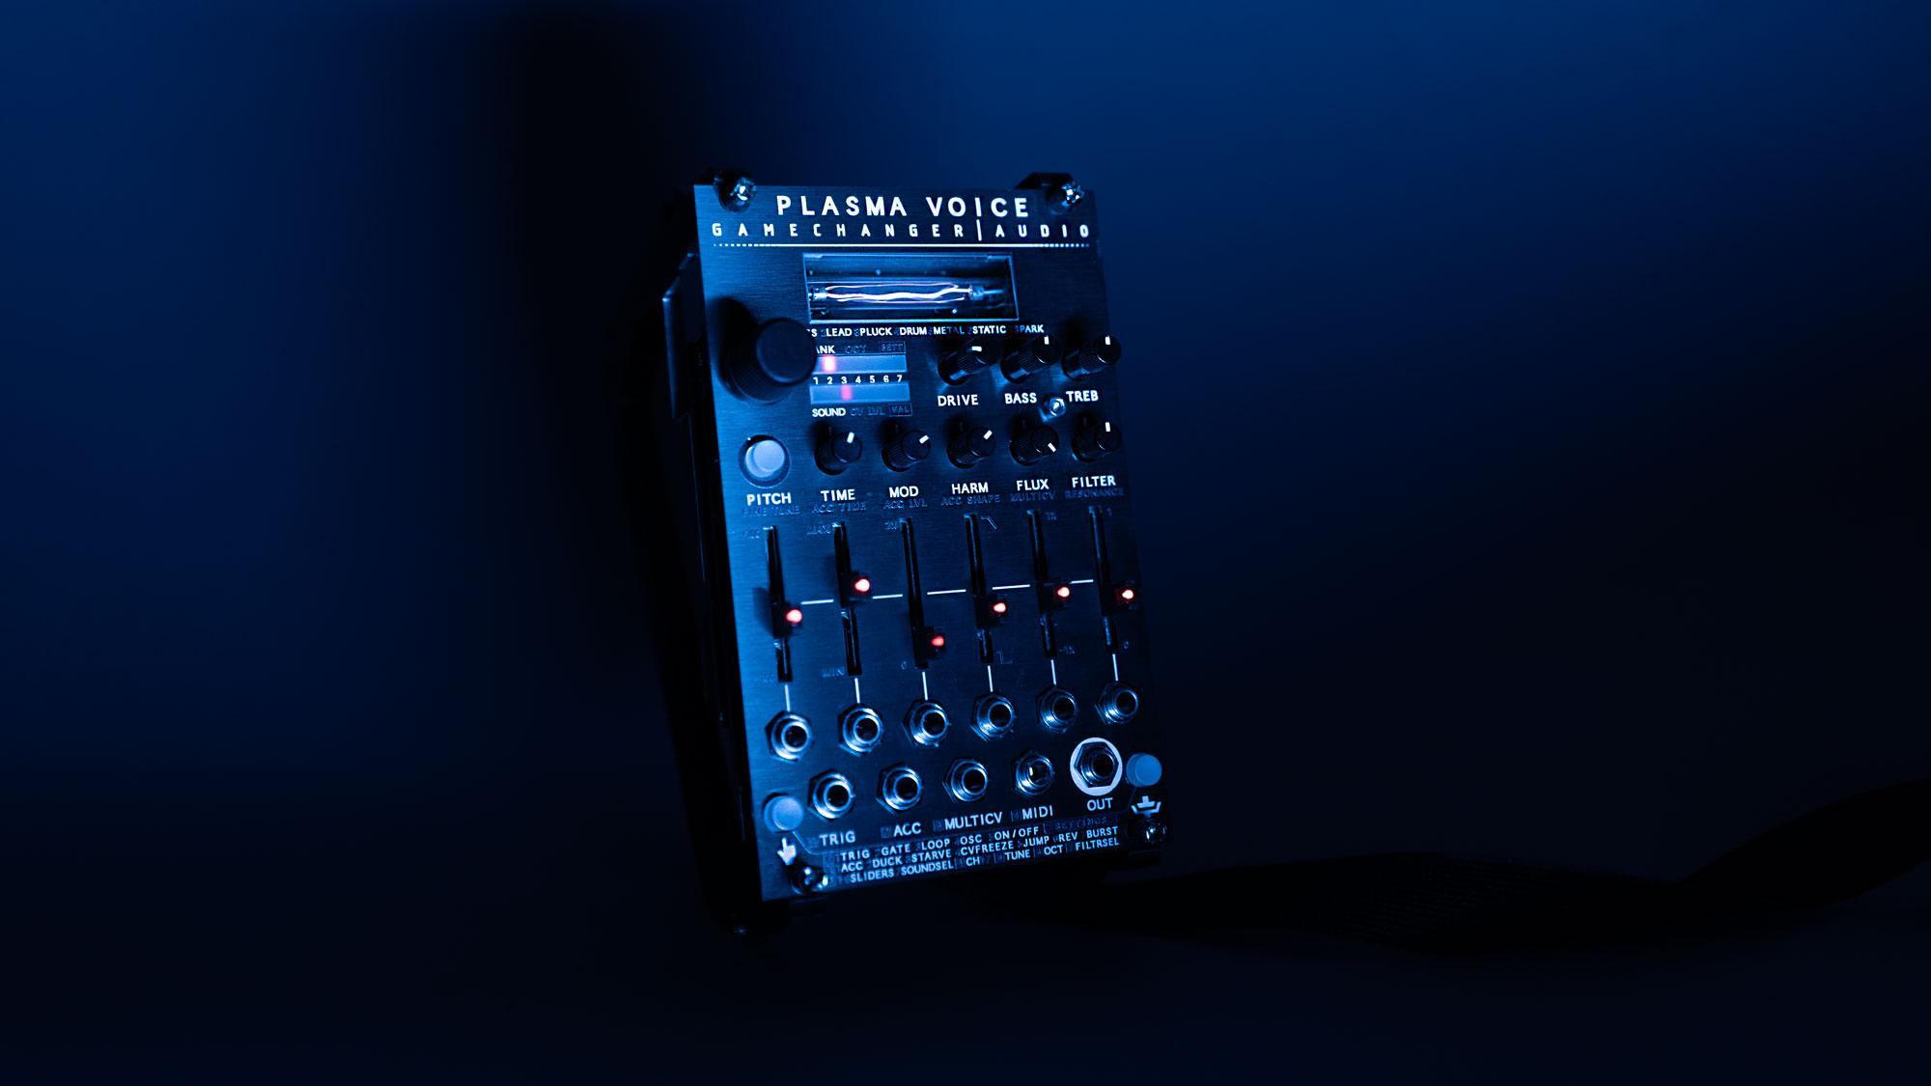

PLASMA VOICE SPECS AND FEATURES LIST

PLASMA VOICE engine

- Proprietary plasma tube driver and electromagnetic discharge detector
- 49 transformable SOUNDS across 7 BANKS
- SOUNDS are complex digital synth engines that modulate the PLASMA tube driver to achieve various sounds. The engine building blocks are tube driver pulse width and frequency modulation, sample pitch modulation, envelope time stretch, wavefold, crossmod, suboctave modulation

Analog signal path

- Soft clipping DRIVE circuit
- BASS and TREBLE frequency boost/cut EQ section
- Analog state variable VCF (selectable 12dB/Oct LP or HP) with resonance amplifier
- Analog output VCA
- VCF and VCA are digitally controlled with internal analog control voltages
- Audio output level +/-8V max

Controls

- 6 center Indent SLIDER potentiometers
  - PITCH +/- 1 oct (fine tune and octave settings are also available)
  - TIME – envelope time stretch
  - MOD – pitch modulation effect
  - HARM – harmonic content effect
  - FLUX – electric artefact effect
  - FILTER – cutoff with and without envelope modulation
- 5 center indent ATTENUVERTERS for CV inputs
- ALT button for accessing the alternative SLIDER functions for FINE TUNE, ACCENT parameters and FILTER RESONANCE
- Manual TRIGGER / GATE button
- CLUTCH button for temporary parameter editing buffer
- Push & turn ENCODER and a 7:7 LED indicator for SOUND & BANK selection, octave select and navigating the settings menu

CV & TRIGG

- 7 CV inputs. One for each SLIDE and 1 assignable MULTI CV input as an additional CV for any of the SLIDERS or BANK & SOUND selection
- Pitch CV 1V/Oct, +/-10V range
- Parameter CV, +/-5V range
- TRIGGER and ACCENT inputs: 2V minimum, rising and falling edge detect.
- 5 TRIGGER input modes: TRIG, GATE, LOOP, OSC, ON/OFF
- 7 ACCENT modes: ACC, DUCK, STARVE, CVFREEZE, JUMP, REVERSE, BURST

Settings options

- 5 TRIGGER modes
(TRIG, GATE, LOOP, OSCILLATE, ON/OFF)
- 7 ACCENT modes
(ACENT, DUCK, STARVE, CV FREEZE, PITCH JUMP, REVERSE, BURST)
- MULTICV assignment
- MIDI channel select
- Center pitch select
- Master octave offset
- FILTER mode select
- Auto save of all settings

MIDI

- 3.5mm MIDI IN jack, (DIN5 to 3.5mm adapter included)
- MIDI support: Notes, Velocity, CC panel control, PC BANK & SOUND change, PC settings change, Channel 10 General Percussion Key Map, Pitchwheel, Modwheel
- Potential firmware update via MIDI SysEx

Tech Specs

- Voltage: +/-12V DC, (10-16 pin cable included)
- Power draw: Peak 220mA at +12V (mean 75mA), 35mA at -12V. 0 at +5V
- Size: 16HP (W x H: 81.3 x 128.5mm)
- Max depth: 35mm excl. knobs, 54mm incl. knobs
- Mass: 190g

[FACEPLATE]
