PLUS PEDAL LISTING INFO

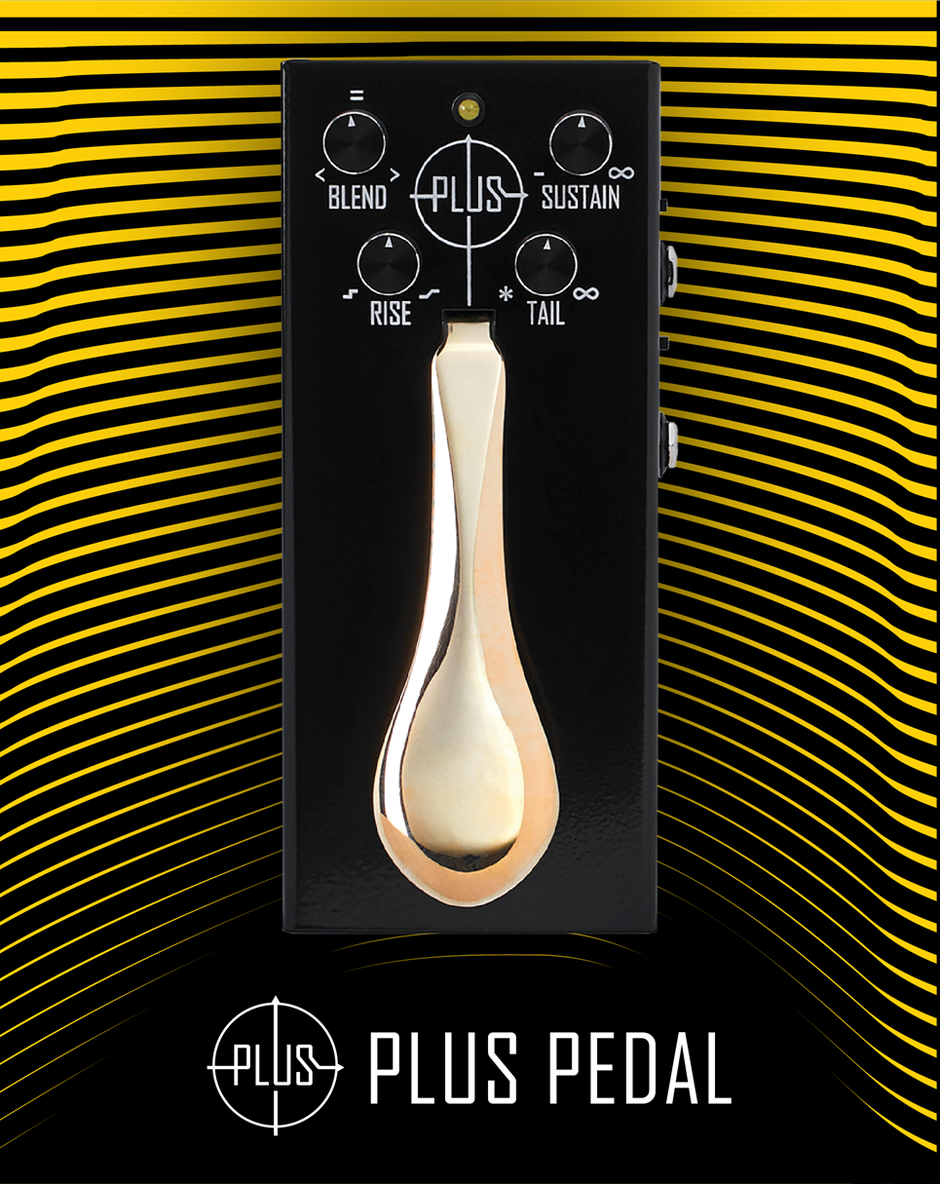

SKU INFO
Product name | PLUS Pedal
Full name in listings | Gamechanger Audio PLUS Pedal
Manufacturer’s SKU | GCAPU
UPC | 750258555158
Product category | Effect Pedals
Manufacturer | Gamechanger Audio
Made in | Made in EU, Riga, Latvia

PRODUCT PHOTOS AND VIDEOS
Product photos available online:
https://www.dropbox.com/sh/45ffc4mciymrvju/AACcURJq_Y2F6wcclbWBHM3Sa/ASSETS%20PLUS%20PEDAL/PHOTOS?dl=0&subfolder_nav_tracking=1

Suggested product videos:
By Andy Martin, Reverb https://www.youtube.com/watch?v=DEvMxy8r7Zk
By Gamechanger Audio https://www.youtube.com/watch?v=j_R5FuF096g
By Mike Hermans https://www.youtube.com/watch?v=ssvC0DkpZBE

SHORT PRODUCT DESCRIPTION
The PLUS pedal uses a proprietary real-time audio sampling algorithm to generate long, smooth layers of sustain out of any audio input signal. Compared to other “freeze” effects (based on granular synthesis or reverb engines) the PLUS Pedal fully preserves the core sound of your instrument, including picking dynamics, tone and pickup settings, vibrato, harmonics and other nuances. Most importantly, the PLUS Pedal has no limitations in terms of polyphony or timbre. You can use it with complex chords, as well as with single notes on a mono synthesizer.
The PLUS pedal offers many different uses. Accompany your solos with sustaining chords. Build rich ambient textures and harmonically evolving soundscapes. With a flip of a switch and quick knob adjustments the PLUS turns into an ambient machine. Experimentation with other effects in the PLUS pedal’s FX loop opens up endless possibilities of sound sculpting. The sturdy brass piano-style foot pedal becomes part of your instrument. The sensation of playing the PLUS compares to a real piano or a wah-wah pedal.
- Precise control over sustain dynamics with RISE (attack) and TAIL (decay) knobs;
- Different musical applications with two distinct multi-layer sustain modes;
- Achieve organic and natural tones by dialing in gradual low pass filter with the SUSTAIN knob;
- Many routing options with wet/dry and mix/dry outputs and an FX loop;
- More expression with 2 level volume sensitivity on the brass pedal.

PRODUCT DETAILS
User manual: https://www.gamechangeraudio.com/wp-content/uploads/2018/02/PLUS_manual_download.pdf
Power supply is not included. Plus Pedal uses standard 9V DC center negative pedal power supply of at least 200 mA.

Inputs:
Inputs: | IN, RETURN
Input Type | 1/4” Unbalanced TS
Input Impedance | 1MΩ
Max Input Level | +6.8dBu
Outputs:
Outputs: | OUT, CLEAN OUT, SEND
Output Type | 1/4” Unbalanced TS
Output Impedance | 100Ω
Max Output Level | +6.8dBu

Max ADC input | -1.8dBu
Max DAC output | +5.2dBu
Sample Rate | 26kHz
A/D D/A Conversion | 16 bit
Frequency Response Analog/Digital | 20Hz to 22kHz/13kHz
Signal to Noise Ratio | -97 dB (A weighted); ref = max level, 22 kHz bandwidth
THD | -84 dB, ref= 6dBu, 1kHz
Controls | 2-position foot pedal, Potentiometers: BLEND, SUSTAIN, RISE, TAIL, Switches: GROUP/SINGLE, SPLIT/MIX, additional footswitch input.
Indicator | 3-level check and pedal state indicator
Connectors | IN, CLEAN OUT/FSW, OUT, SEND, RETURN
Power Consumption | 1.8W
Power Requirements | min 200mA, 9VDC, center negative 2.1 x 5.5 mm plug
Product Dimensions | WLH 90 x 195 x 72 mm (3.55 x 7.7 x 2.8 in)
Product Weight | 1020 g (2.25 lbs)
EXTENDED PRODUCT DESCRIPTION
The PLUS pedal is a new kind of audio processing engine that offers piano-style sustain for electric guitars and all other melodic instruments. This is more than just a stompbox – it is a vast extension of your instrument that bridges the gap between rhythm and lead playing and lets players explore new territories.
Real-time audio sampling
The PLUS pedal uses a proprietary real-time audio sampling algorithm to generate long, smooth layers of sustain out of any audio input signal. Compared to other “freeze” effects (based on granular synthesis or reverb engines) the PLUS Pedal fully preserves the core sound of your instrument, including picking dynamics, tone and pickup settings, vibrato, harmonics and other nuances. Most importantly, the PLUS Pedal has no limitations in terms of polyphony or timbre. You can use it with complex chords, as well as with single notes on a mono synthesizer.
Musical uses
The PLUS pedal offers many different uses. Accompany your solos with sustaining chords. Build rich ambient textures and harmonically evolving soundscapes. With a flip of a switch and quick knob adjustments the PLUS turns into an ambient machine. Experimentation with other effects in the PLUS pedal’s FX loop opens up endless possibilities of sound sculpting.
The sturdy brass piano-style foot pedal becomes part of your instrument. The sensation of playing the PLUS compares to a real piano or a wah-wah pedal. From jazz-voice leading to heavy post-rock drones – the Plus Pedal allows the guitarist to do more with the instrument! A useful tool in any context - live performances, songwriting & arrangement, creating drones, ambient soundscapes, cinematic sound effects, and much more.
Musical training and improvisation
It is also a fantastic tool for aural training and practicing improvisation. Instead of thinking about which scale shape fits over what changes – the PLUS Pedal focuses all of your attention on listening to the tonal relationships between the chord and the notes you play on top.
Key features:
- Precise control over sustain dynamics with RISE (attack) and TAIL (decay) knobs;
- Different musical applications with two distinct multi-layer sustain modes;
- Multiple layers allow stacking up to 5 notes or chords simultaneously;
- Achieve organic and natural tones by dialing in gradual low pass filter with the SUSTAIN knob;
- Many routing options with wet/dry and mix/dry outputs;
- FX loop to further change the sustained sounds with other effect pedals.
- More expression with 2 level volume sensitivity on the brass pedal;
- Unique design – a brilliant combination of a guitar stomp-box and piano’s damper pedal. The steel case will make sure it lasts, and the classy look will make it fit on any stage, from café guitarist to rock band to jazz trio.

AMAZON BULLET POINTS
The PLUS Pedal is a piano style sustain pedal for guitars and all other melodic instruments. It samples, sustains and layers any melodic sound made by any instrument.
It allows to compose otherwise impossible song arrangements using just one instrument.
Create lush layered soundscapes and ambiances without multi-effect setups.
Transform chords into synth-like pads and beautiful textures.
Power supply is not included. The PLUS Pedal uses standard 9 V DC center negative pedal power supply.

AMAZON PRODUCT DESCRIPTION
The PLUS pedal is a new kind of audio processing engine that offers piano style sustain for electric guitars and all other melodic instruments. This is more than just a stompbox, it is a vast extension of your instrument that bridges the gap between rhythm and lead playing and lets players explore new territories.
The PLUS pedal uses a proprietary real time audio sampling algorithm to generate long, smooth layers of sustain out of any audio input signal. Compared to other freeze effects (based on granular synthesis or reverb engines) the PLUS Pedal fully preserves the core sound of your instrument, including picking dynamics, tone and pickup settings, vibrato, harmonics and other nuances. Most importantly, the PLUS Pedal has no limitations in terms of polyphony or timbre. You can use it with complex chords, as well as with single notes on a mono synthesizer.
The PLUS pedal offers many different uses. Accompany your solos with sustaining chords. Build rich ambient textures and harmonically evolving soundscapes. With a flip of a switch and quick knob adjustments the PLUS turns into an ambient machine. Experimentation with other effects in the PLUS pedal’s FX loop opens up endless possibilities of sound sculpting.
The sturdy brass piano-style foot pedal becomes part of your instrument. The sensation of playing the PLUS compares to a real piano or a wah-wah pedal. From jazz-voice leading to heavy post-rock drones the Plus Pedal allows the guitarist to do more with the instrument! A useful tool in any context like live performances, songwriting & arrangement, creating drones, ambient soundscapes, cinematic sound effects, and much more.
It is also a fantastic tool for aural training and practicing improvisation. Instead of thinking about which scale shape fits over what changes. The PLUS Pedal focuses all of your attention on listening to the tonal relationships between the chord and the notes you play on top.

