PLASMA RACK LISTING INFO

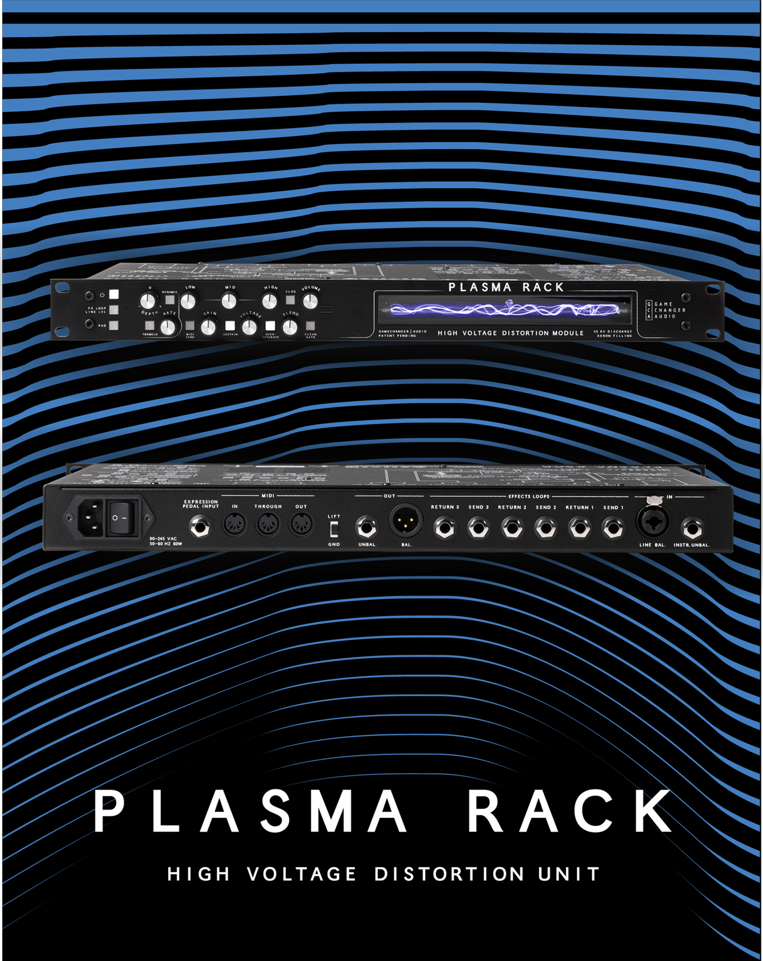

SKU INFO
Product name | PLASMA Rack
Full name in listings | Gamechanger Audio PLASMA Rack
Manufacturer’s SKU | GCAPRA
UPC | 750258555196
Product category | Studio outboard gear
Manufacturer | Gamechanger Audio
Made in | Made in EU, Riga, Latvia

PRODUCT PHOTOS AND VIDEOS
Product photos available online:
https://www.dropbox.com/sh/45ffc4mciymrvju/AAAR1qUJ6ManIgDWKSqw6zUaa/ASSETS%20PLASMA%20RACK/Plasma%20Rack%20Photoshoot%2004.05?dl=0&subfolder_nav_tracking=1

Suggested product video:
By Gamechanger Audio https://www.youtube.com/watch?v=XQA_Ml0oqgY

SHORT PRODUCT DESCRIPTION
The PLASMA Rack distorts audio signal by transforming it into visible high voltage electric discharge in a xenon tube. The wide frequency spectrum works great with various sound sources. The PLASMA rack has a unique gritty distortion and carefully designed controls. The naturally occurring noise gate effect interacts with the VOLTAGE knob and input level. This combined with the DRY/WET mix knob makes PLASMA Drive perfect for drum machines and fx tracks.
Modulating the xenon lamp creates extraordinary TREMOLO and RING MOD sounds. The CLEAN GATE effect ads the signature PLASMA gating effect to the clean signal. The SUSTAINER circuit allows to dial in sputtery broken sounds without loosing sustain. The OVERSATURE circuit overloads the tube and adds upper harmonics and changes the dynamic response. This together with sophisticated I/O and full MIDI implementation makes for a powerful post-production and post-destruction machine.
- Distortion that integrates in a studio with instrument/line level signal processing and balanced & unbalanced I/O;
- Previously unheard gritty CLEAN GATE effect that can be applied on dry sound without distortion;
- Dynamic TREMOLO / RING MODULATOR effect modulates the xenon lamp resulting in a unique effect that can be controlled by the input level;
- Distort stereo tracks with two units in master/slave configuration;
- Recall your distortion presets with MIDI PC and control all parameters with MIDI CC.

PRODUCT DETAILS
User manual: https://www.gamechangeraudio.com/wp-content/uploads/2019/07/Plasma_Rack_User_Manual.pdf
Specifications IO
Unbalanced inputs
Connector | Tip-Sleeve ¼” Jack
Impedance | 1 MΩ
Maximum input level | + 11 dBu
Maximum undistorted input level | 0 dBu (Gain setting at minimum)
Type | Instrument input, RF filtered, true bypass to unbalanced output
Balanced inputs
Connector | Combo connector: Female XLR and Tip-Ring-Sleeve ¼” (Pin 2 and Tip hot)
Impedance | 4.38 kΩ; 1.5 kΩ (PAD switch on)
Maximum input level | +17 dBu (Clamped by protection devices)  +37 dBu (PAD switch on, clamped by protection devices)
Maximum undistorted input level | +2dBu (Gain setting at minimum)  +22 dBu (PAD switch on, Gain setting at minimum)
Type | Mic/Line input, RF filtered, true bypass to balanced output
Unbalanced outputs
Connector | Tip-Sleeve ¼” Jack
Impedance | 220Ω
Maximum output level | +7 dBu
Balanced output:
Connector | Male XLR (Pin 2 Hot)
Impedance | 200 Ω
Maximum output level | + 10 dBu
FX loop send (1-3):
Connector | Tip-Sleeve ¼” Jack
Impedance | 100 Ω
Maximum output level | +12 dBu (Line level)  -6 dBu (Instrument level)
FX loop return (1-3)
Connector | Tip-Sleeve ¼” Jack
Impedance | 1 MΩ
Maximum input level | +14 dBu
MIDI in/out/through
Connector | 5-pin DIN (180 degree)
Type | Optically isolated input, RF filtered
Expression pedal
Connector | Tip-Ring-Sleeve ¼” (Wiper tip, CCW ring, CW sleeve)
Type | Designed for potentiometer-based expression pedals, RF filtered
Gain and signal levels
Preamp gain range | -26 to +12 dB
Unbalanced input | recommended level for 0dB gain setting: -15 dBu
Balanced input (PAD switch off) | recommended level for 0dB gain setting: -9 dBu
Balanced input (PAD switch on) | recommended level for 0dB gain setting: +11 dBu
FX loop level (Line) | +4 dBu at recommended input level
FX loop level (Instrument) | -15 dBu at recommended input level
Volume control gain | -80 to +12 dB
PAD attenuation | -20 dB, applies for balanced input only
Equalization
Low frequency | 10 Hz, -20 to 20 dB Low-pass shelving filter
Mid frequency | 600 Hz, -6 to 6 dB
High frequency | 20 kHz, -10 to 10 dB, High-pass shelving filter
Type | Baxandall, MIDI controllable
Tremolo
Rate range | 0.85 to 2600 Hz
Depth control | 0 – 100%, in (positive range) or out (negative range) of phase between clean and distorted signals
Tube
Gas | Xenon
Discharge voltage | 5.5 kV

EXTENDED PRODUCT DESCRIPTION
The PLASMA RACK is a 1U sized high-end audio effects unit designed for professional and studio use. By using a High voltage step-up flyback transformer, PLASMA RACK turns your instrument’s signal into a rapid series of electric discharges in a Xenon-filled tube. These powerful discharges (up to 5500 Volts) then get picked up by a specially designed electromagnetic receiver and turned back into audio-level signal. This process results in a large amount of punishingly heavy distortion, and also saturates the sound with a wide range of harmonics and overtones. The PLASMA distortion together with added effects, sophisticated I/O and full MIDI implementation makes for a powerful post-production and post-destruction machine.
Distortion characteristics
The harmonic artifacts, created as a byproduct of the high-voltage discharge are uncommon in traditional signal amplification, and therefore PLASMA distortion is unlike anything you have heard before. The PLASMA Rack produces large amount of non-linear harmonic saturation that causes extremely rich and responsive attacks, and brings out screeching sharp overtones and harmonics. The way the PLASMA tube reacts with different instruments and sound sources simply cannot be recreated with any other analog machine, plug-in or by digital modeling. The scope of distortion intensity goes from sputtery broken sounds to full saturation and sustain all the way to totally oversaturated tones. The level of distortion is controlled with INPUT GAIN and VOLTAGE knobs. The OVERSATURE mode overpowers the PLASMA tube and enhances upper harmonics and overtones.
Natural noise gate and CLEAN GATE
When input level drops below the PLASMA lamps voltage threshold the electrical discharge within the gas-filled tube is interrupted. This creates a gating effect which is unique to the PLASMA distortion and is a huge part of the flavor of this distortion. The extremely fast gate creates the sputtering sounds with each attack and decay/release of a sound. It creates strong contrasts between sounds so it works really well with beats and drum tracks. The gating effects interacts with the INPUT GAIN and VOLTAGE. The SUSTAIN mode allows to prolong the sustain when using low VOLTAGE (high gate threshold) settings.
CLEAN GATE applies the special PLASMA gating to the dry signal even if the distorted wet signal is not mixed in. This allows to apply the same sputtering gate sounds as a texture without distorting the signal. This effect has a wide range of applications, such as - crushing drums, removing sustain from cymbals, or adding a flickering quality to melodic lines.
Tremolo and ring modulation
The PLASMA RACK features a diverse TREMOLO section that affects both the DRY and the WET signals in or out of phase. The tremolo is achieved by modulating the PLASMA tube. The tremolo speed goes into ring modulation territory. The tremolo rate and ring modulation frequency can be controlled with MIDI CC message and an expression pedal. The effect also has an envelope follower which allows to control the tremolo and ring modulation depth with the input level. Finally, the tremolo section interacts with the CLEAN GATE effect allowing to add the flickering PLASMA gate to the clean sound at the rate of the tremolo.
Signal routing
The PLASMA Rack has a balance and unbalanced i/O. It works with both instrument and line level signals. It is a mono unit, however it is designed to work in master/slave configuration for stereo signal processing. There are 3 effect loops in different parts of the signal chain that also work both with instrument and line level signals.
Workflow
The PLASMA Rack signal processing is fully analog, but the parameters can be digitally controlled. It has full MIDI implementation, each parameter can be controlled with MIDI CC and PC messages and the rack has 8 user preset slots plus a default boot-up preset and settings. The expression pedal input can be rerouted to any parameter and saved on global or preset basis.

AMAZON BULLET POINTS
The PLASMA Rack is a high voltage distortion rackmount module featuring electric discharge in a xenon tube. High voltage distortion is a new and previously unexplored method of achieving signal clipping.
Instead of using LED circuits, transistors or vacuum tubes for clipping, the PLASMA RACK uses a flyback coil transformer to express audio signal as a series of continuous high voltage discharges within a xenon-filled tube. In essence you are playing a bolt of electricity, and the electrical discharges produced by your instrument are instantly converted back into an analog audio signal.
The PLASMA Rack produces a quick, responsive, and extremely heavy distortion with tons of unique character and a very powerful noise gating effect.
The wide frequency response spectrum, unique gating and distortion character works great with various sound sources like beats, synths, guitars, drum tracks, bass tracks, fx tracks and more.
The PLASMA Rack provides hours and hours of exciting sonic exploration both during track printing and post-production. The unit works with line and instrument signal levels and is fully midi controllable.

AMAZON PRODUCT DESCRIPTION
The PLASMA RACK turns your instruments signal into a rapid series of electric discharges in a Xenon-filled tube. High voltage discharges then get picked up by a specially designed electromagnetic receiver and turned back into audio-level signal. This process results in punishingly heavy distortion saturation with a wide range of harmonics and overtones.
The harmonic artifacts, created as a byproduct of the high voltage discharge are uncommon in traditional signal amplification, and therefore PLASMA distortion is unlike anything you have heard before. The PLASMA Rack produces large amount of non linear harmonic saturation that causes extremely rich and responsive attacks, and brings out screeching sharp overtones and harmonics. The scope of distortion intensity goes from sputtery broken sounds to full saturation and sustain all the way to totally oversaturated tones.
When input level drops below the PLASMA lamps voltage threshold the electrical discharge within the gas filled tube is interrupted. This creates a fast and sputtery gating effect which is unique to the PLASMA distortion and is a huge part of the flavor of this distortion. It creates strong contrasts between sounds so it works really well with beats and drum tracks.
CLEAN GATE applies the special PLASMA gating to the dry signal even if the distorted wet signal is not mixed in. This allows to apply the same sputtering gate sounds as a texture without distorting the signal.
The PLASMA RACK features a TREMOLO section that affects both the DRY and the WET signals in or out of phase. The tremolo is achieved by modulating the PLASMA tube and the tremolo speed goes into ring modulation territory. The effect also has an envelope follower which allows to control the tremolo and ring modulation depth with the input level.
The PLASMA Rack has a balance and unbalanced I/O. It works with both instrument and line level signals. It is a mono unit, however it is designed to work in master/slave configuration for stereo signal processing. There are 3 effect loops in different parts of the signal chain that also work both with instrument and line level signals. The PLASMA Rack signal processing is fully analog, but the parameters can be digitally controlled. It has full MIDI implementation.

