PLASMA PEDAL LISTING INFO

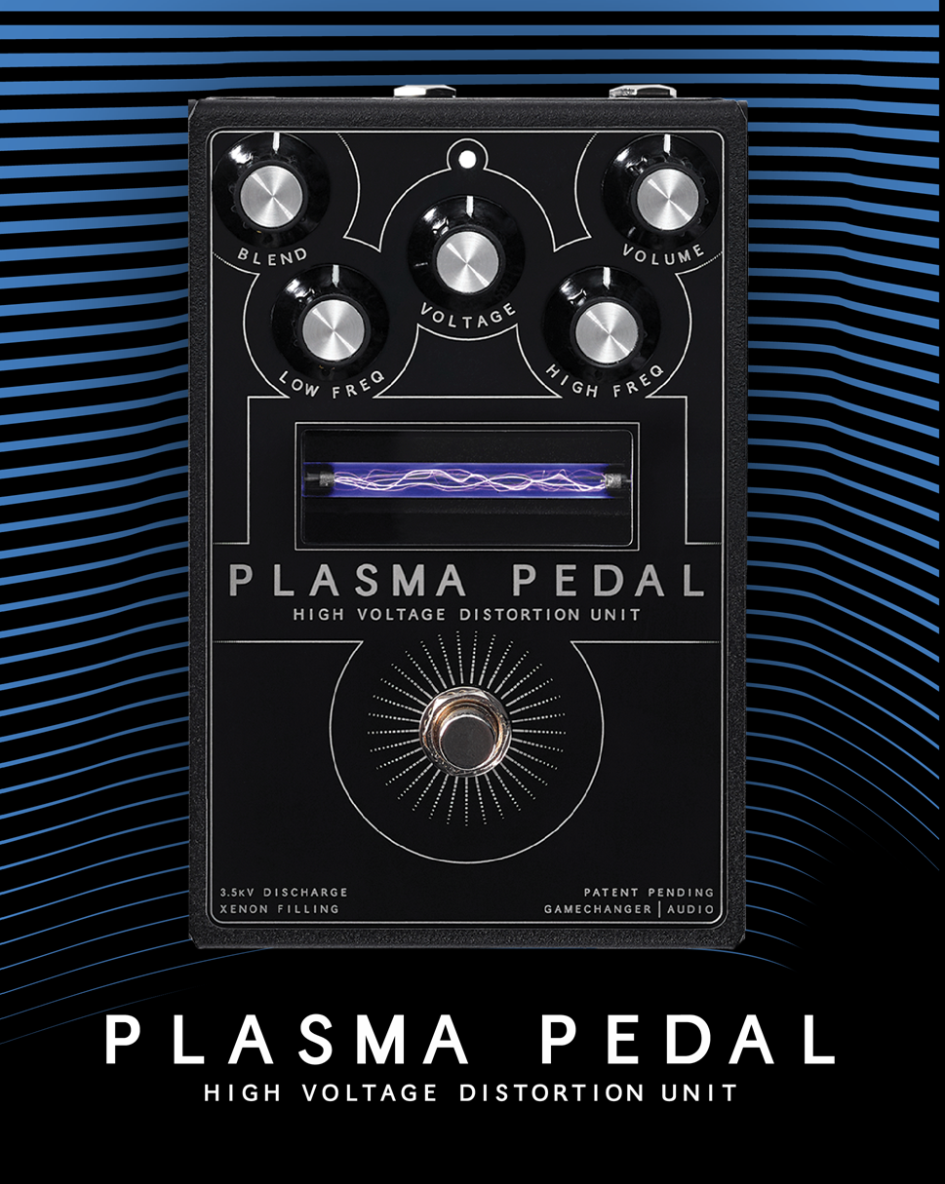

SKU INFO
Product name | PLASMA Pedal
Full name in listings | Gamechanger Audio PLASMA Pedal
Manufacturer’s SKU | GCAPA
UPC | 750258555172
Product category | Effect Pedals
Manufacturer | Gamechanger Audio
Made in | Made in EU, Riga, Latvia

PRODUCT PHOTOS AND VIDEOS
Product photos available online:
https://www.dropbox.com/sh/45ffc4mciymrvju/AAD9uXi-HUIMpxo7FF-9eeCha/ASSETS%20PLASMA%20PEDAL/PHOTOS?dl=0&subfolder_nav_tracking=1

Suggested product videos:
By Andy Martin https://www.youtube.com/watch?v=_AZj5tc8EmA
By Gamechanger Audio https://www.youtube.com/watch?v=IIUL8VET2kI
By Mike Hermans https://www.youtube.com/watch?v=QD7fzS2NR-c

SHORT PRODUCT DESCRIPTION
The PLASMA PEDAL is a revolutionary approach within the realm of overdrive and distortion, as it is a new and previously unexplored method of achieving signal clipping. Instead of using LED circuits, transistors or vacuum tubes to produce overdrive, the PLASMA PEDAL transforms your instrument’s live signal into a series of continuous high-voltage discharges within a xenon-filled tube. In essence – you are playing a bolt of electricity, and the electrical discharges produced by the PLASMA Tube are instantly converted back into audio signal.
The harmonic artifacts, created as a byproduct of the high-voltage discharge are uncommon in traditional signal amplification, and therefore PLASMA distortion is unlike anything you have heard before. The way the PLASMA tube reacts with different instruments and sound sources simply cannot be recreated with any other analog machine, plug-in or by digital modeling.
PLASMA PEDAL is designed primarily for guitarists and bass players, but it is also an awesome distortion tool for all sorts of synths, electronic beats, and instrument samples.
- VOLTAGE knob to control the sustain, gate threshold and overall character of the distortion.
- Add crazy PLASMA distortion on top your clean or dirty signal with the BLEND knob;
- Wide frequency spectrum controlled with the LOW and HIGH FREQ knobs;
- PLASMA is great on bass - use the BLEND knob and CLEAN EQ switch on the back of the pedal to toggle EQ section bypass on the dry sound.
Simplified Wet Signal Chain:
Input -> (EQ if on) -> Transformer to High Voltage -> Xenon Tube -> Antenna that picks up the electromagnetic vibrations surrounding the Tube -> (EQ if off) -> Blend with Clean -> Output

PRODUCT DETAILS
User manual: https://www.gamechangeraudio.com/wp-content/uploads/2019/04/Plasma_Pedal_Manual.pdf
Power supply is not included. The PLASMA Pedal uses standard 9V DC center negative pedal power supply of at least 250 mA.
Input Type | 1/4” Unbalanced TS
Input Impedance | 1MΩ
Max Input Level | 7Vpp (+10dBu)
Output Type | 1/4” Unbalanced TS
Output Impedance | 100Ω
Max Output Level | 7Vpp (+10dBu)
Power connector | Center negative 2.1 x 5.5 mm barrel plug (the standard 9V)
Frequency Response | 20Hz to 22kHz
Controls | True bypass foot-switch button, Potentiometers: BLEND, VOLTAGE, VOLUME, LOW FREQ, HI FREQ, CLAEN EQ toggle switch
Indicator | Check indicator white LED
Connectors | IN, OUT, DC input
Power Requirements | 300mA, 9VDC
Peak Power Consumption | 2.7 W
Mean Power Consumption | 1 W
Power Consumption while silent | 0.025 W
Dimensions | LWH 148 x 96 x 70 mm / 5.1 x 3.8 x 2.8 in
Weight | 840 g / 1.8 lbs

EXTENDED PRODUCT DESCRIPTION
The PLASMA PEDAL is a revolutionary approach within the realm of overdrive and distortion, as it is a new and previously unexplored method of achieving signal clipping. Instead of using LED circuits, transistors or vacuum tubes to produce overdrive, the PLASMA PEDAL transforms your instrument’s live signal into a series of continuous high-voltage discharges within a xenon-filled tube. In essence – you are playing a bolt of electricity, and the electrical discharges produced by the PLASMA Tube are instantly converted back into audio signal.
Unique Harmonic Saturation
The harmonic artifacts, created as a byproduct of the high-voltage discharge are uncommon in traditional signal amplification, and therefore PLASMA distortion is unlike anything you have heard before. The way the PLASMA tube reacts with different instruments and sound sources simply cannot be recreated with any other analog machine, plug-in or by digital modeling.
Naturally occurring noise gate
The naturally occurring noise gate creates strong contrasts between staccato notes, as well as eliminating all unwanted noise and pick-up hum. As soon as you stop playing the electrical discharge within the gas-filled tube is interrupted, and the pedal will not produce any output signal at all. This feature allows you to achieve extreme contrasts between individual notes.
BLEND Control
The BLEND knob sets the balance of the dry and wet signal mix. This allows to add the PLASMA distortion on top of the clean signal or even already dirty tone. The later results in a very rich and fat tone. Use the PLASMA even in your amps FX loop and use the BLEND to combine preamp gain with PLASMA distortion. When playing around with sharply gated broken sound, the BLEND knob can be used to retain the decay of the sound.
Extremely Wide EQ
The PLASMA Pedal produces a very wide frequency spectrum with massive low end and sharp and screeching high end. The LOW and HIGH FREQ knobs control this by boosting and cutting the lows and highs. Cut the lows and highs and boost the volume for mid-boosted sound, or boost the lows and highs for an impressive wall of sound. The EQ section can be applied to both dry and wet signal or wet signal alone, which paired with the BLEND knob is a very useful feature for the bass guitar.
Use with other instruments
The PLASMA Pedal is designed primarily for guitarists and bass players, but it is also an awesome distortion tool for all sorts of synths, electronic beats, and instrument samples.
Key features:
- VOLTAGE knob to control the sustain, gate threshold and overall character of the distortion.
- Add crazy PLASMA distortion on top your clean or dirty signal with the BLEND knob;
- Wide frequency spectrum controlled with the LOW and HIGH FREQ knobs;
- PLASMA is great on bass - use the BLEND knob and CLEAN EQ switch on the back of the pedal to toggle EQ section bypass on the dry sound.

AMAZON BULET POINTS
High voltage distortion is a new and previously unexplored method of achieving signal clipping. You are playing a bolt of electricity, and the electrical discharges produced by the PLASMA Tube are instantly converted back into audio signal.
Unique frequency response with grainy and sizzling distortion textures. Sharp and massive pick attacks because of the naturally occurring noise gate.
Wide scope if picking response. From sputtery broken sounds, to rhythmical staccato playing, all the way to rich and very long sustaining lead sounds.
Harmonic transparency allows to play even the most complex chords. Suitable and designed to use with guitars, bass, synthesizers and drum machines.
Power supply is not included. Plasma Pedal uses standard 9 V DC center negative pedal power supply.

AMAZON PRODUCT DESCRIPTION
The PLASMA PEDAL is a revolutionary approach within the realm of overdrive and distortion, as it is a new and previously unexplored method of achieving signal clipping. Instead of using LED circuits, transistors or vacuum tubes to produce overdrive, the PLASMA PEDAL transforms your instruments live signal into a series of continuous high voltage discharges within a xenon filled tube. In essence you are playing a bolt of electricity, and the electrical discharges produced by the PLASMA Tube are instantly converted back into audio signal.
The harmonic artifacts, created as a byproduct of the high voltage discharge are uncommon in traditional signal amplification, and therefore PLASMA distortion is unlike anything you have heard before.
As soon as you stop playing the electrical discharge within the gas filled tube is interrupted, and the pedal will not produce any output signal at all. This feature allows you to achieve extreme contrasts between individual notes, by eliminating all of the in between noises created by the instruments pickups or by humming strings.
The BLEND knob sets the balance of the dry and wet signal mix. This allows to add the PLASMA distortion on top of the clean signal or even already dirty tone. The later results in a very rich and fat tone.
The PLASMA Pedal produces a very wide frequency spectrum with massive low end and sharp and screeching high end. The LOW and HIGH FREQ knobs control this by boosting and cutting the lows and highs. The EQ section can be applied to both dry and wet signal or wet signal alone, which paired with the BLEND knob is a very useful feature for the bass guitar.
The PLASMA Pedal is designed primarily for guitarists and bass players, but it is also an awesome distortion tool for all sorts of synths, electronic beats, and instrument samples.

