PLASMA DRIVE EURORACK LISTING INFO

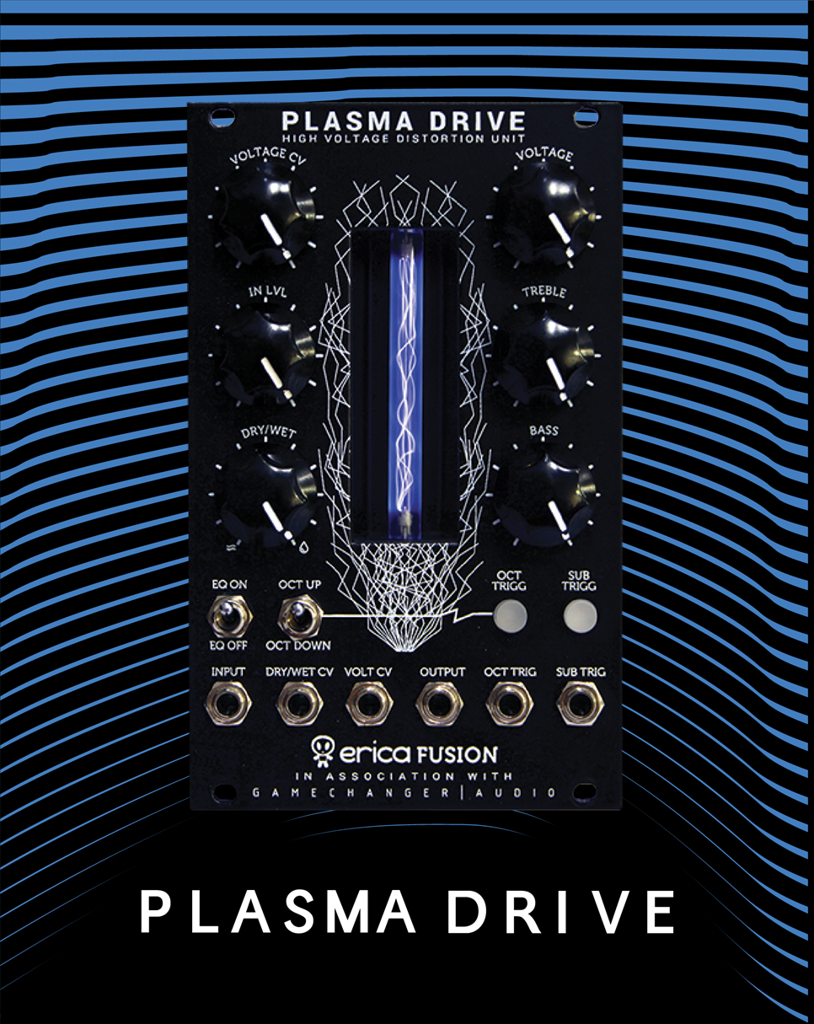

SKU INFO
Product name | PLASMA Eurorack module
Full name in listings | Gamechanger Audio PLASMA Eurorack module
Manufacturer’s SKU | GCAPEU
EAN | 4751030823737
Product category | Modular synthesizers
Manufacturer | Gamechanger Audio
Made in | Made in EU, Riga, Latvia

PRODUCT PHOTOS AND VIDEOS
Product photos available online:
https://www.dropbox.com/sh/45ffc4mciymrvju/AACXax21wuNv8coE4JnqSnkMa/ASSETS%20PLASMA%20EURORACK?dl=0&subfolder_nav_tracking=1

Suggested product videos:
By Erica Synths https://www.youtube.com/watch?v=Z4pMhM27Am8
By Tin Shed Modular (AU) https://www.youtube.com/watch?v=5WZkuKKjdxk

SHORT PRODUCT DESCRIPTION
The PLASMA Drive distorts audio signal by transforming it into visible high voltage electric discharge in a xenon tube. It is the PLASMA Pedals sound in eurorack format.
The HIGH VOLTAGE DISTORTION offers a very wide frequency spectrum making it perfect with bass lines and synth pads. The naturally occurring noise gate effect reduces the distortion decay depending on where the VOLTAGE knob is set. This combined with the DRY/WET mix knob makes the PLASMA Drive perfect for drum machines and noise tracks. It interacts with the dynamics of the input signal. The EQ section can be applied to both the dry and wet or only the wet signal. The PLASMA Drive features octave up and down tracking oscillators for gritty sonic experimentation.
- Control over the intensity of distortion with CV inputs for VOLTAGE and DRY/WET blend;
- Add rich textures with octave up, down and sub tracking oscillators with CV triggers;
- Extended control over gain with separate VOLTAGE and INPUT LEVEL controls. Experimentation with both of them extends the available distortion nuances.
We designed the PLSMA Drive eurorack module in collaboration with our friends and eurorack visionaries ERICA SYNTHS.

PRODUCT DETAILS
User manual: https://www.gamechangeraudio.com/wp-content/uploads/2019/04/Plasma_Module_Manual.pdf
Power supply is not included. Plasma Drive uses conventional eurorack PSU ribbon cable of ±12VDC, 300mA (positive rail 200 mA, negative rail 100 mA).
The expected life of the xenon tube is 10,000 to 70,000 hours of active playing. The xenon tube is replaceable.
Audio input leve | up to 20V ptp
EQ low freq boost/cut | ±9dB, 600Hz corner freq.
EQ hi freq boost/cut | ±10dB, 1.5kHz corner freq.
CV input level | -10V – +10V
Panel width | 16HP
Panel height | 3U
Module depth | 45 mm, 50 mm with the protective casing
Peak power requirement | 200mA@+12V, 100mA@-12V

EXTENDED PRODUCT DESCRIPTION
The PLASMA Drive eurorack module is a collaboration between Gamechanger Audio and Erica Synths, an established and recognized modular synthesizer brand from Latvia. Erica Synths are a team of visionaries, engineers and musicians who create modules and instruments that are different in terms of sound, looks and functions.
Similar to the PLASMA Pedal, the PLASMA Drive Eurorack boosts audio signal to 3000V and transforms it into a series of continuous high-voltage discharges in a xenon-filled tube. In essence you are playing a lightning bolt of electricity, and the electrical discharges produced by your instrument are instantly converted back into an analogue audio signal. The result – a quick, responsive, and extremely heavy distortion with tons of unique character.
The PLASMA Drive eurorack module brings the sounds of the PLASMA Pedal to the modular world. The functions of the pedal are complemented with CV control over the level of distortion and a dry/wet mix. The Module introduces tracking oscillators for a new Octave Up & Two-Octave Down function, thus adding even more harmonics to the original signal. Tracking oscillators can be switched on/off manually or via trigger signals. The PLASMA Drive module is powered with conventional eurorack PSU ribbon cable and the power consumption is around 250mA.
Unique Harmonic Saturation
The harmonic artifacts, created as a byproduct of the high-voltage discharge are uncommon in traditional signal amplification, and therefore PLASMA distortion is unlike anything you have heard before. The way the PLASMA tube reacts with different instruments and sound sources simply cannot be recreated with any other analog machine, plug-in or by digital modeling.
Naturally occurring noise gate
The naturally occurring noise gate creates strong contrasts between staccato notes, as well as eliminating all unwanted noise. As soon as there is no input signal the electrical discharge within the gas-filled tube is interrupted, and the module will not produce any output signal at all. This feature allows you to achieve extreme contrasts between individual notes.
BLEND Control
The BLEND knob sets the balance of the dry and wet signal mix. This allows to add the PLASMA distortion on top of the clean. When playing around with sharply gated broken sound, the BLEND knob can be used to retain the decay of the sound.
Extremely Wide EQ
The PLASMA Drive module produces a very wide frequency spectrum with massive low end and sharp and screeching high end. The TREBLE and BASS knobs control this by boosting and cutting the lows and highs. Cut the lows and highs and boost the volume for mid-boosted sound, or boost the lows and highs for an impressive wall of sound. The EQ section can be applied to both dry and wet signal or wet signal alone.

AMAZON BULET POINTS
High voltage distortion is a new and previously unexplored method of achieving signal clipping. You are playing a bolt of electricity, and the electrical discharges produced by the PLASMA Tube are instantly converted back into audio signal.
Unique frequency response with grainy and sizzling distortion textures. Sharp and massive attacks because of the naturally occurring noise gate.
Wide scope if input level response. From sputtery broken sounds, to rhythmical staccato playing, all the way to rich and very long sustaining sounds.
1 octave up and 1 and 2 octave down tracking oscillators. CV control over distortion and dry wet mix. Assignable pre and post effect equalizer.
Harmonic transparency allows to play even the most complex chords.

AMAZON PRODUCT DESCRIPTION
The PLASMA Drive eurorack module is a collaboration between Gamechanger Audio and Erica Synths, an established and recognized modular synthesizer brand from Latvia. Erica Synths are a team of visionaries, engineers and musicians who create modules and instruments that are different in terms of sound, looks and functions.
The PLASMA Drive Eurorack boosts audio signal to 3000V and transforms it into a series of continuous high voltage discharges in a xenon filled tube. In essence you are playing a lightning bolt of electricity, and the electrical discharges produced by your instrument are instantly converted back into an analogue audio signal. The result is a quick, responsive, and extremely heavy distortion with tons of unique character.
The Module features octave up & two octave down tracking oscillators, thus adding even more harmonics to the original signal. Tracking oscillators can be switched on and off manually or via trigger signals.
The naturally occurring noise gate creates strong contrasts between staccato notes, as well as eliminating all unwanted noise. As soon as there is no input signal the electrical discharge within the gas filled tube is interrupted, and the module will not produce any output signal at all. This feature allows you to achieve extreme contrasts between individual notes.
The BLEND knob sets the balance of the dry and wet signal mix. This allows to add the PLASMA distortion on top of the clean. When playing around with sharply gated broken sound, the BLEND knob can be used to retain the decay of the sound.
The PLASMA Drive module produces a very wide frequency spectrum with massive low end and sharp and screeching high end. The TREBLE and BASS knobs control this by boosting and cutting the lows and highs. Cut the lows and highs and boost the volume for mid boosted sound, or boost the lows and highs for an impressive wall of sound. The EQ section can be applied to both dry and wet signal or wet signal alone.

