PLASMA COIL LISTING INFO

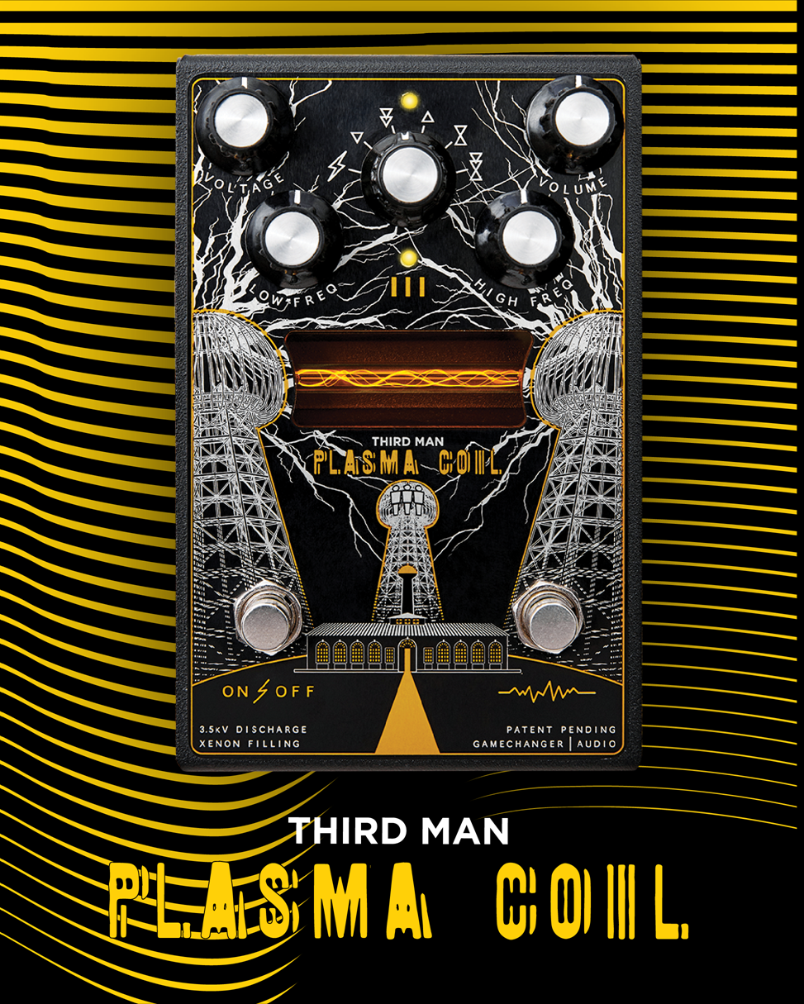

SKU INFO
Product name | PLASMA Coil
Full name in listings | Gamechanger Audio Third Man Records Plasma Coil
Manufacturer’s SKU | GCAPCO
UPC | 750258555219
Product category | Effect Pedals
Manufacturer | Gamechanger Audio
Made in | Made in EU, Riga, Latvia

PRODUCT PHOTOS AND VIDEOS
Product photos available online:
https://www.dropbox.com/sh/45ffc4mciymrvju/AACrvLle_iSCEjkiv15QGmgFa/ASSETS%20PLASMA%20COIL/PHOTOS?dl=0&subfolder_nav_tracking=1

Suggested product videos:
By Gamechanger Audio https://www.youtube.com/watch?v=W_oMLyxEis8
By Jack White https://www.youtube.com/watch?v=uCM__zcakWk
By Andy Martin https://www.youtube.com/watch?v=AxMmcFRCHx8
By Pete Thorn https://www.youtube.com/watch?v=ZQA7yG1GKpY

SHORT PRODUCT DESCRIPTION
Designed together with Jack White and Third Man Records, the PLASMA Coil takes HIGH VOLTAGE DISTORTION to new heights by adding intense, gritty and glitchy octave up and down effects:
- Volume boost;
- 2 subharmonic modes (bitcrush-style octave down);
- 1 upper harmonic mode (Octafuzz-style octave Up);
- 2 mixed modes (upper and lower harmonics combined).
The PLASMA Coil’s octave effects are created by a unique analog circuit designed specifically for driving a high-voltage transformer. The subharmonic modes will add massive low end to higher notes and the Upper Harmonic modes will add fire and razorblades to riffs and low-tuned chords.
The PLASMA Pedal’s BLEND control is removed, so you always are on 100% PLASMA.
The PLASMA Coil is even more grittier than PLASMA Pedal and the added effects make it a very expressive distortion unit.

PRODUCT DETAILS
User manual: https://www.gamechangeraudio.com/wp-content/uploads/2019/11/PLASMA_COIL_MANUAL_V2_WEB2.pdf
Power supply is not included. The PLASMA Coil uses standard 9V DC center negative pedal power supply of at least 250 mA.
The expected life of the xenon tube is 10,000 to 70,000 hours of active playing. The xenon tube is replaceable.

Input Type | 1/4” Unbalanced TS
Input Impedance | 1MΩ
Max Input Level | 7Vpp (+10dBu)
Output Type | 1/4” Unbalanced TS
Output Impedance | 100Ω
Max Output Level | 7Vpp (+10dBu)
Power connector | Center negative 2.1 x 5.5 mm barrel plug (the standard 9V)
Frequency Response | 20Hz to 22kHz
Controls | True bypass footswitch button, Effect footswitch button Potentiometers: VOLTAGE, VOLUME, LOW FREQ, HI FREQ, Effect Latch toggle switch
Indicator | Check indicator white LED
Connectors | IN, OUT, DC input
Power Requirements | 300mA, 9VDC
Peak Power Consumption | 2.7 W
Mean Power Consumption | 1 W
Power Consumption while silent | 0.025 W
Dimensions | LWH 148 x 96 x 70 mm / 5.1 x 3.8 x 2.8 in
Weight | 840 g / 1.8 lbs

EXTENDED PRODUCT DESCRIPTION
The PLASMA Coil is a version of the PLASMA Pedal designed together with Jack White and Third Man Records.
The PLASMA Coil is a revolutionary way of producing distortion by converting your instrument’s signal into a series of high-voltage plasma discharges in a sealed xenon filled tube.
The result is an incredibly sharp and sizzling overdrive that is extremely clear, responsive, and most importantly fun! This patent-pending technology of high-voltage electric discharge also acts as a natural noise-gating device that creates strong contrasts between staccato notes, as well as eliminating all unwanted noise and pick-up hum. The PLASMA Coil’s electric discharge tube produces beautiful visible bolts of lightning that react to the input signal, thus creating a captivating experience for all players. In essence you are playing a bolt of electricity.
Effects
Compared to the regular PLASMA Pedal the Jack White’s version doesn’t have the dry/wet signal blend control, but instead has gritty and glitchy octave up and down effects:
- Volume boost;
- 2 subharmonic modes (bitcrush-style octave down);
- 1 upper harmonic mode (Octafuzz-style octave Up);
- 2 mixed modes (upper and lower harmonics combined).
These effects are toggled with the pedals secondary footswitch which can operate both in latching and momentary modes.
Unique Harmonic Saturation
The PLASMA Coil converts your instrument’s signal into a rapid series of electric discharges, which results in a large amount of non-linear harmonic saturation that causes extremely rich and responsive attacks, and brings out screeching sharp overtones and harmonics. These harmonic artefacts, produced as a byproduct of the high voltage discharge are uncommon in traditional signal amplification, and therefore PLASMA Coil’s distortion is unlike anything you have heard before.
Natural Noise Gate
As soon as you stop playing the electrical discharge within the gas filled tube is interrupted, and the pedal will not produce any output signal at all. This feature allows you to achieve extreme contrasts between individual notes, by eliminating all of the in-between noises created by the instrument’s pick-ups or by humming strings.
Extremely Wide EQ
The PLASMA Coil creates the distortion signal from fluctuations in the electromagnetic field surrounding the xenon gas discharge tube. This allows for a very wide range of frequencies. Boost and cut the lows and highs with the dedicated knobs.

